VISUALIZATION –(30-12-2023) Yazhini S

DATA VISUALIZATION

Databricks has built-in support for charts and visualizations in both Databricks SQL and in notebooks.

In Microsoft Azure, you can leverage Power BI for data visualization, allowing you to create compelling reports and dashboards with interactive elements. Power BI integrates seamlessly with various Azure data services like Azure Synapse Analytics, Azure SQL Database, and others.

DATA PROFILE

For data profiling, Azure Data Studio is a tool that helps you explore and understand your data. It provides a platform for querying, exploring, and visualizing data, allowing you to analyze and profile your data effectively.

1)CREATING VISUALIZATION

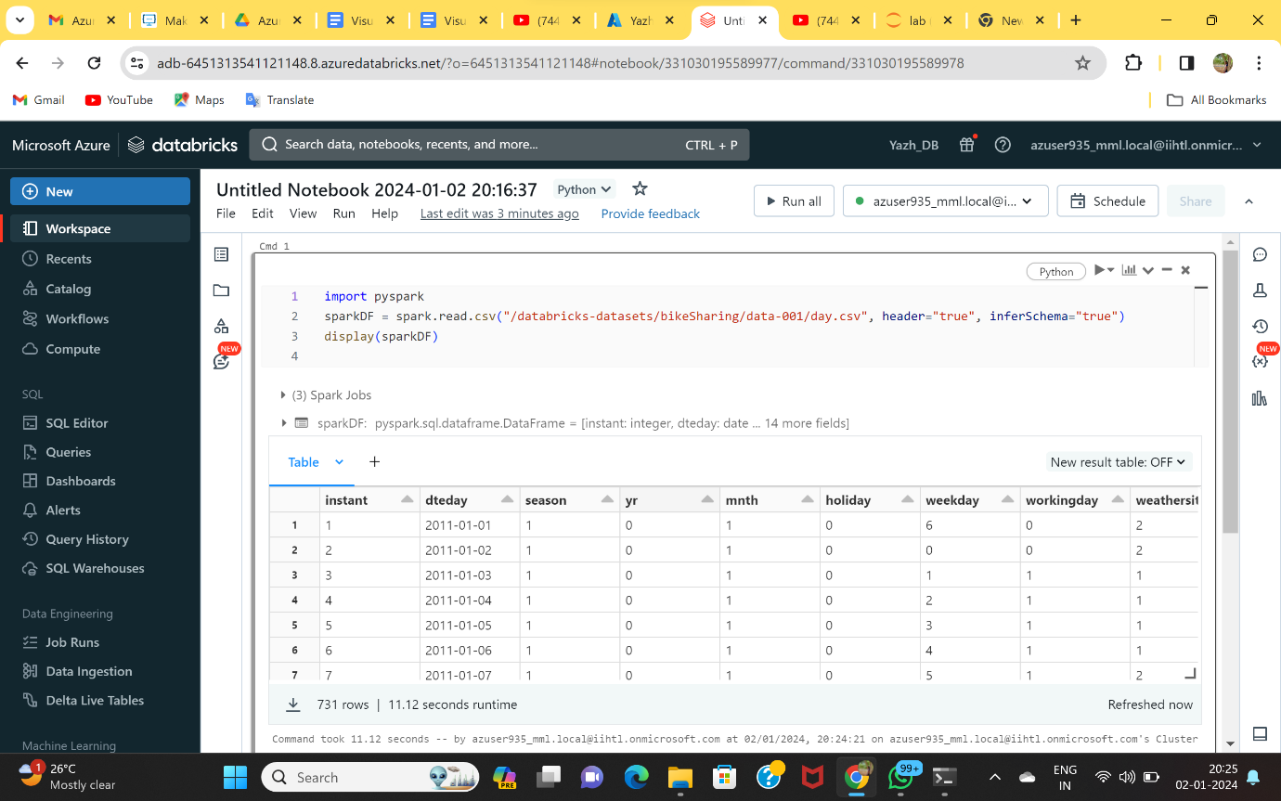

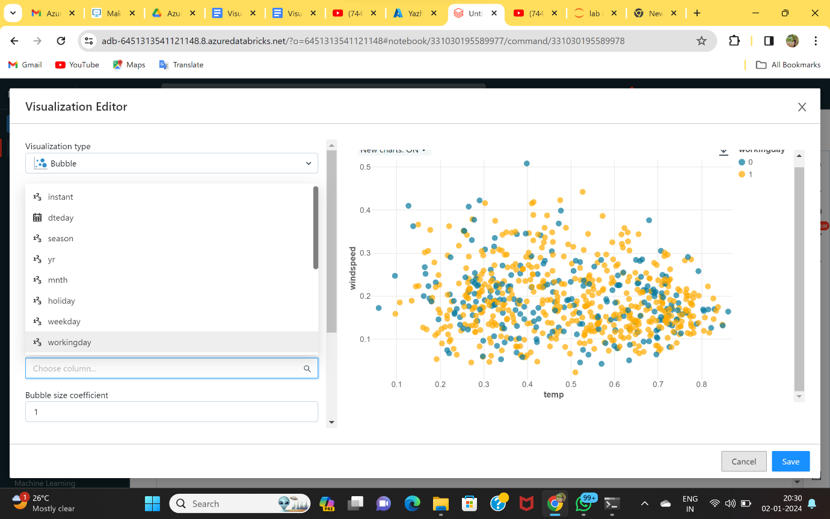

2)CREATING DATA PROFILE

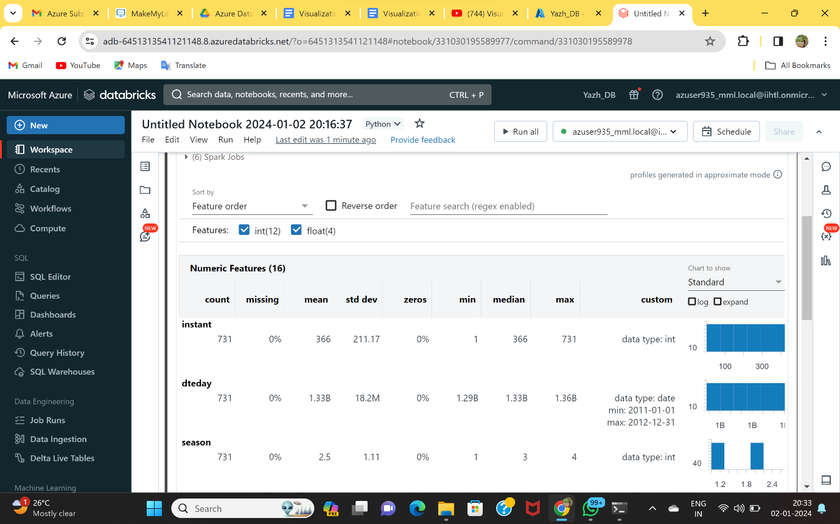

Using Expand to view the chart

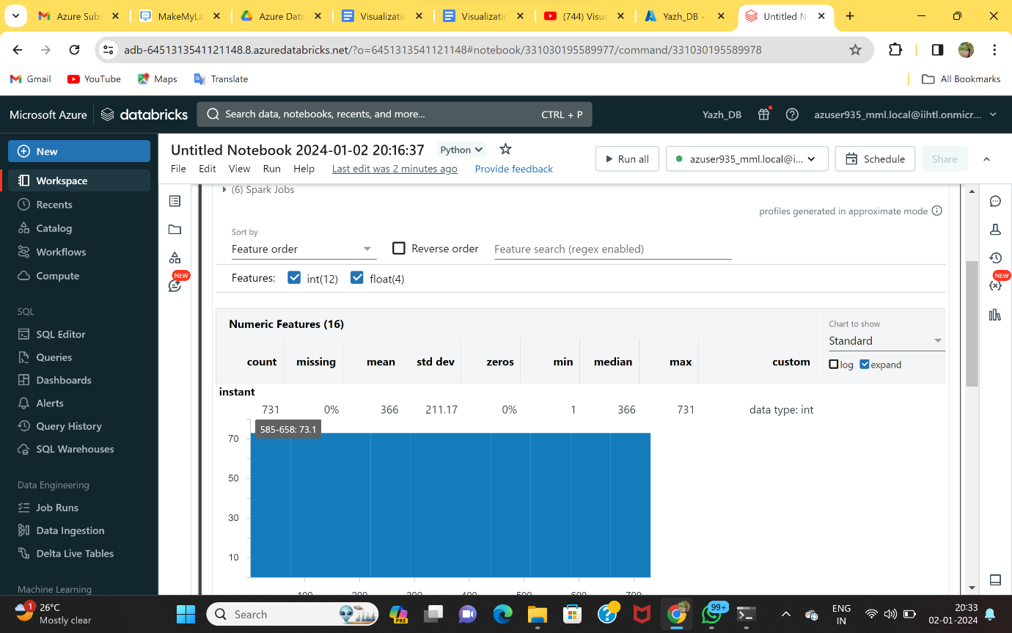

3)RENAMING THE DATA PROFILE

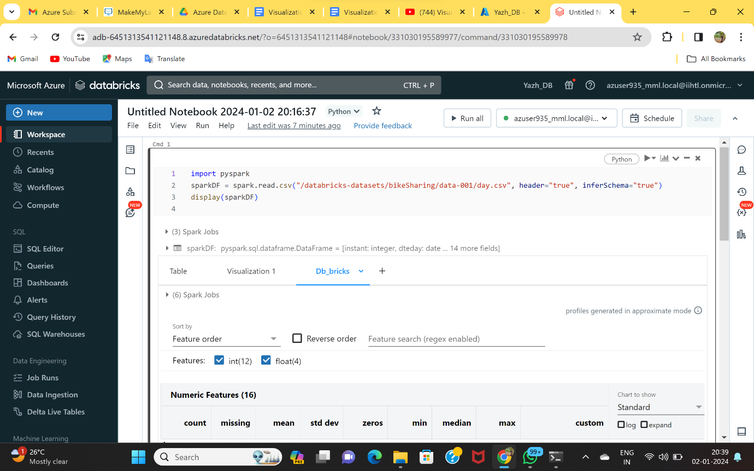

4)CHANGING THE COLOR OF VISUALIZATION

